**Book Assignment**

1. **Find all books whose author is Faisal Abid and display name of book authors and categories**

db.book.find({authors : 'Faisal Abid'}, {title : 1, categories : 1})

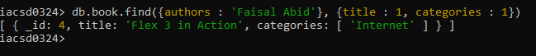

1. **List all the books with category Internet at first position in category array**

db.book.find({'categories.1' : 'Internet'})

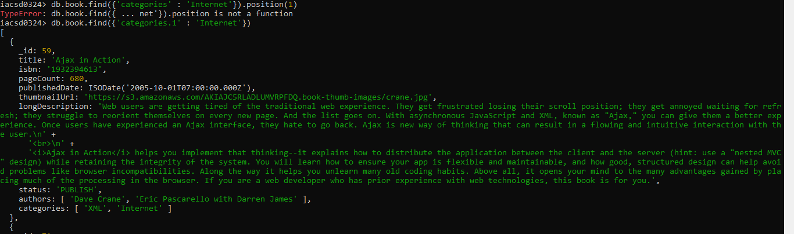

1. **Change the status of books “undergoing change” for books having more than 500 pages and published in 2009**

db.book.updateMany({pageCount : {$gt : 500}, $expr : {$eq : [{$year : '$publishedDate'}, 2009]}}, {$set : {status : 'undergoing change'}})

db.book.find()

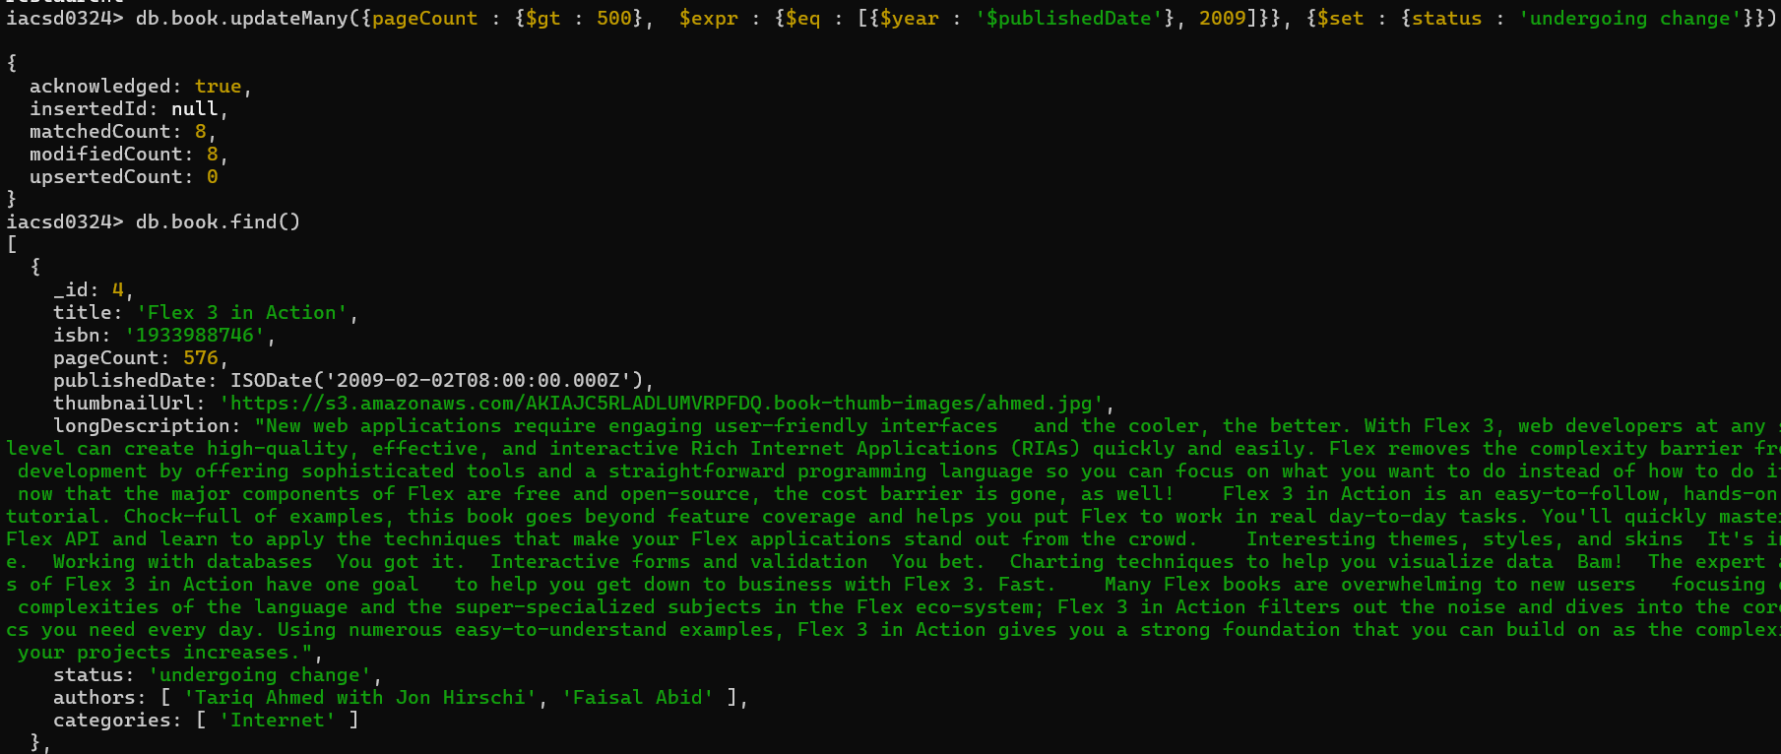

1. **Find all the books containing word highlighting and depth in long description of the book**

db.book.find({longDescription:{$regex :/highlighting|depth/i}})

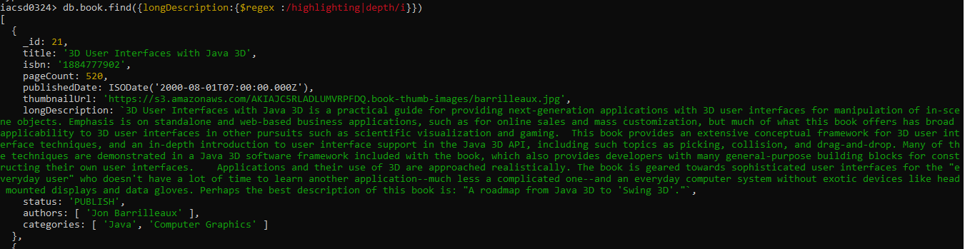

1. **Display all books published in 2009**

db.book.find({$expr : {$eq : [{$year : '$publishedDate'}, 2009]}})

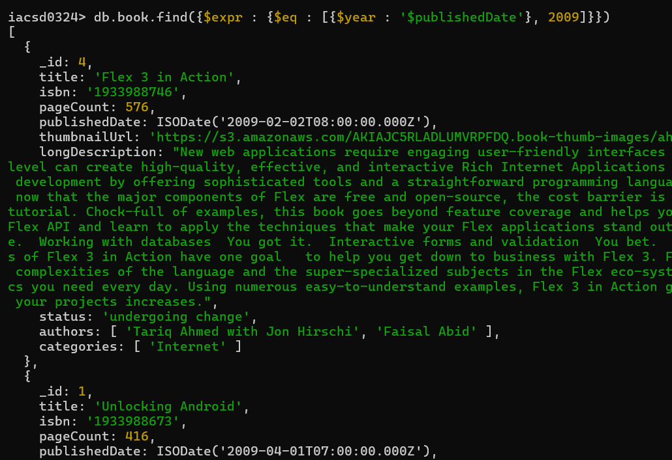

1. **Find all books with pageCount is either 500 or 556 or 670**

db.book.find({pageCount:{$in:[500,556,670]}})

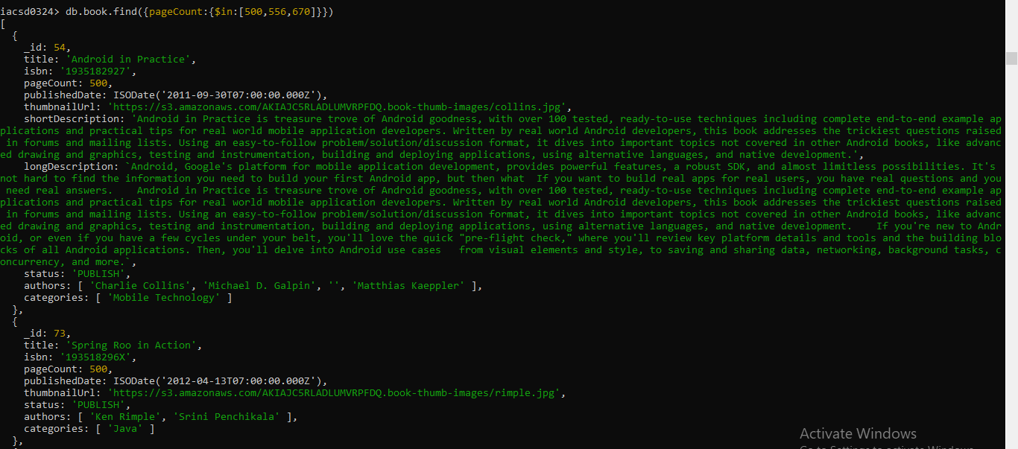

1. **Add 2 categories “kindle” and “hard bind” in all the books if its pageCount >200 and < 500 or number of pages >500**

db.book.updateMany({$or:[{pageCount:{$gt:200,$lt:500}},{pageCount:{$gt:500}}]},{$push : {categories: {$each : ['kindle','hard bind']}}})

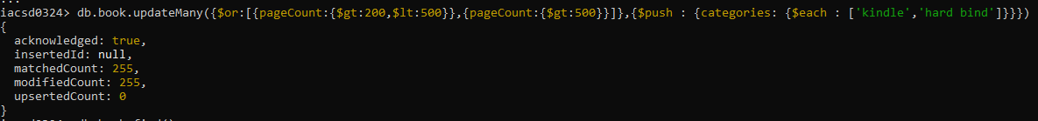

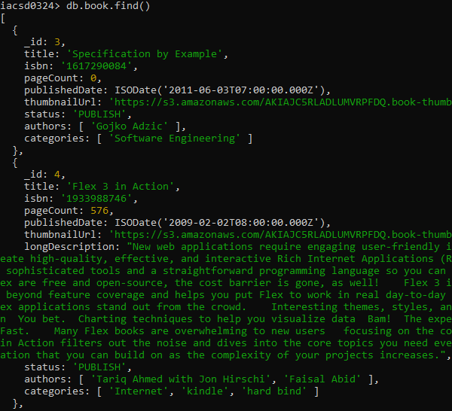

1. **List all the books which has thumbnailUrl key**

db.book.find({},{thumbnailUrl:1,title:1,_id:0}) 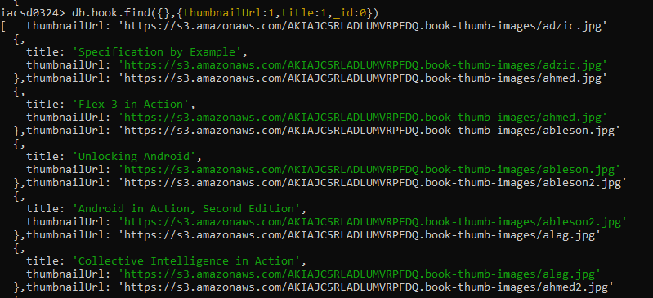

1. **Add key type with values [“fiction”,”moral stories”,”adventurous”] in all books whose title starts with Fl and contains a some where in the name**

db.book.updateMany({title : {$regex : /^Fl|Fl/i}}, {$set : {type : ["ficton", "moral stories", "adventurous"]}} ,{upsert : true})

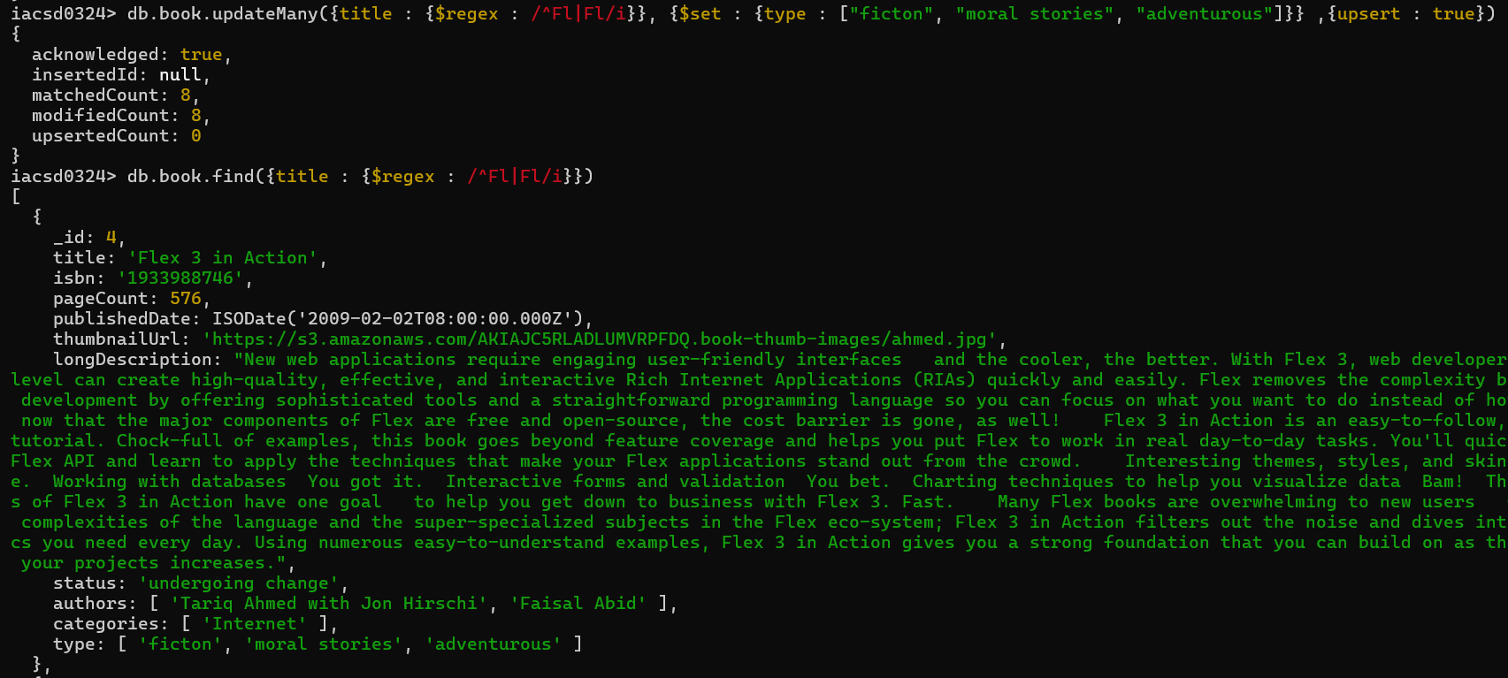

1. **Add a key comments :[{comment:” like the book” ,date:ISODate(“2019-09-01”)},**

db.book.updateMany({publisheddate : ISODate("2019-09-01")}, {$set : { comments : "like the book"}}, {upsert : true})

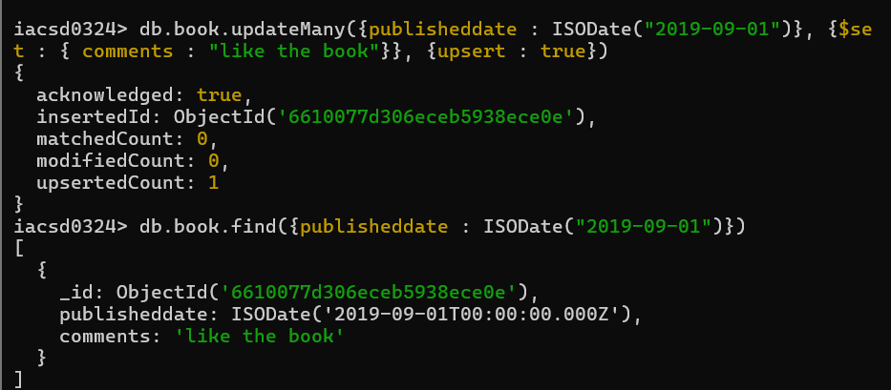

1. **Add new author “myauthor” at position 2 for all books whose title starts with h or m and contains s at 2nd last position**

db.book.updateMany( { "title": { $regex: /^[hm].*s.*[^s]$/i } }, { $push: { "authors": { $each: ["myauthor"], $position: -2 } } } )

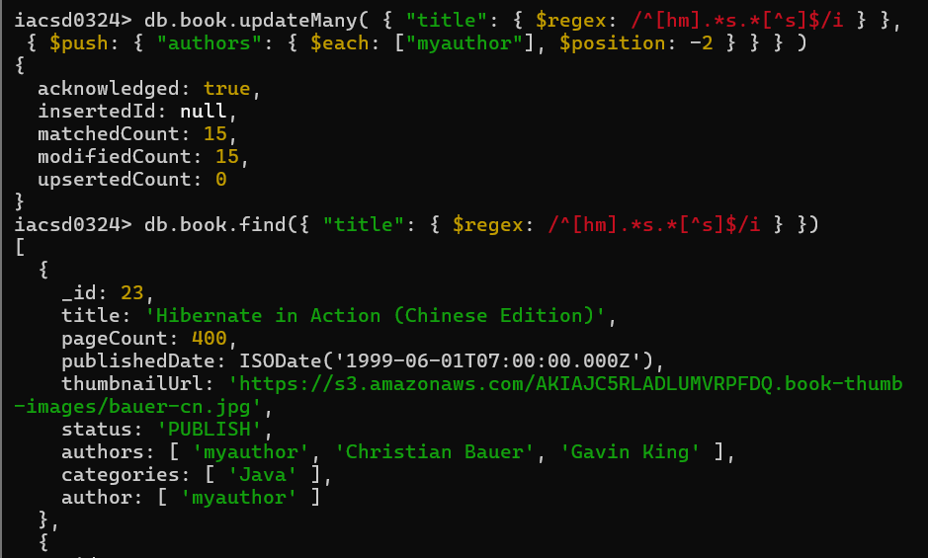

1. **Increase pageCount by 100 for all books whose author at 1 st position is “Gal Shachor”**

db.book.updateMany( { "authors.0": "Gal Shachor" }, { $inc: { "pageCount": 100 } } )

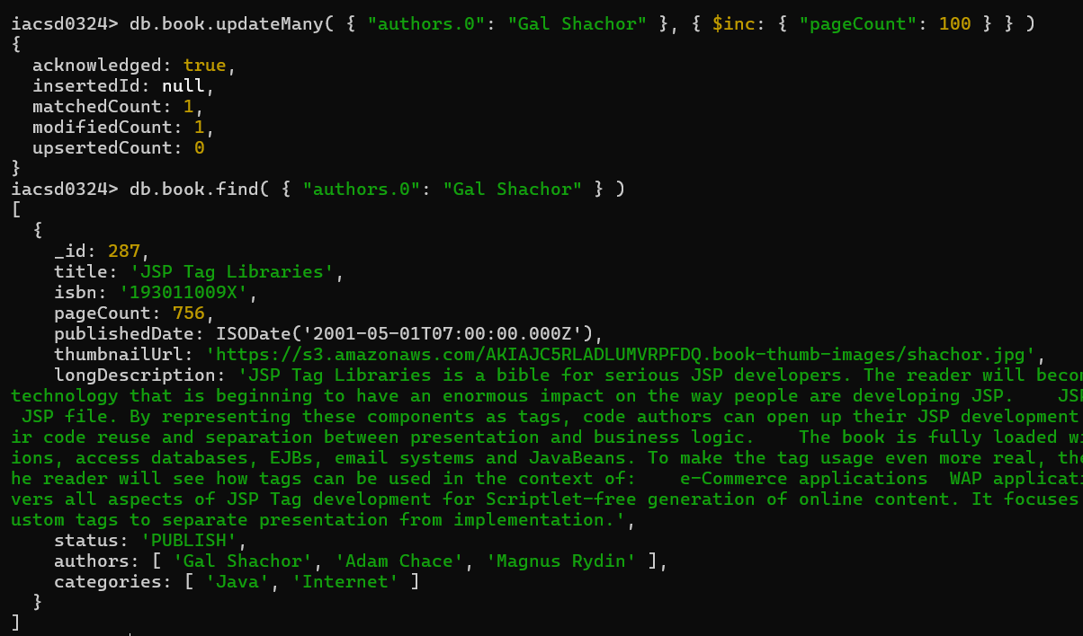

1. **Overwrite “Magnus Rydin" with name “Fr”**

db.book.updateMany({authors : "Magnus Rydin"},{$set : {authors : "Fr"}})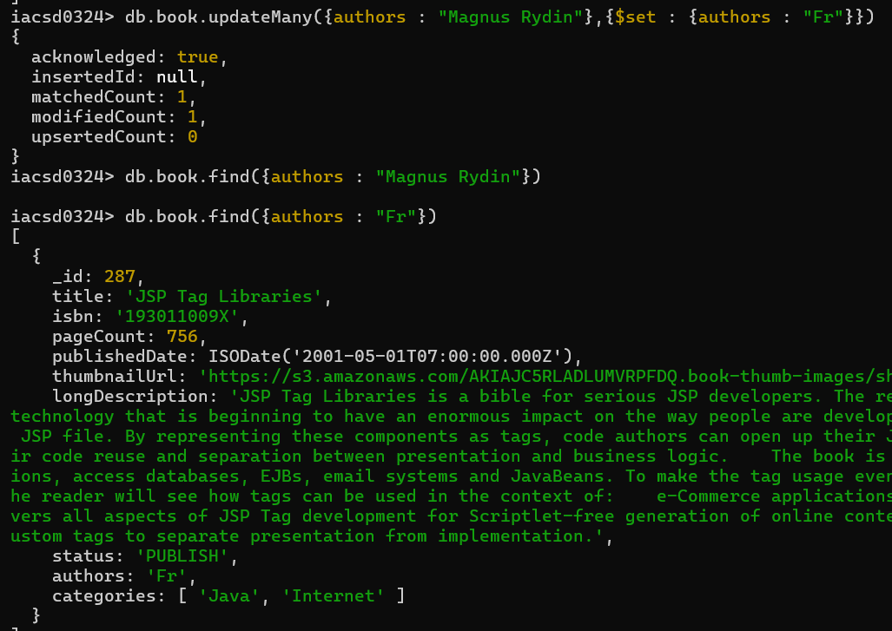

1. **List all books title, status, pageCount, comments for all books with pages > 300 or < 500 or title starts with a or isbn starts with 193**

db.book.find( {$or : [{pageCount : {$gt : 300, $lt : 500}}, {title : /^a/i}, {isbn : /^193/}]}, {title:1, status:1, pageCount:1, comment:1})

